**A Project Report on**

**Automatic details extraction from Payment cards with OCR and OpenCV**

Submitted in partial fulfillment for award of

**Bachelor of Technology**

Degree

in

**Computer Science & Engineering**

By

**K.Yamini (Y15ACS476)**

**M.Umadevi (Y14ACS494)**

**K.Srikar Sharan (Y15ACS462)**

**M.Pradeep (Y15ACS486)**

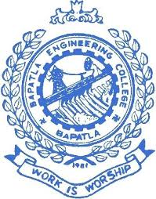

Under the guidance of

**Mr. S.N.Chandra Sekhar, Asst.Prof.**

Department of Computer Science and Engineering

**Bapatla Engineering College**

(Autonomous)

(Affiliated to Acharya Nagarjuna University)

**BAPATLA – 522 102, Andhra Pradesh, INDIA**

**2018-2019**